1. Tokens and Tokenization Process
What is a Token?
A token is a small piece of text that an AI model processes.
A token can be:
- A whole word
- Part of a word
- A punctuation mark
- Sometimes a space or other text fragment
For example:
I love AI.
The model may break it approximately into:
I | love | AI | .
These are tokens.
Token ≠ always one word.
For example, a long or uncommon word may be split into multiple tokens.

What is Tokenization?
Tokenization is the process of breaking text into smaller pieces called tokens before sending it to the AI model.
The process is:
Your text
↓
Tokenization
↓
Tokens
↓
AI Model
↓
Generated tokens
↓
Text response
Simple example
You type:
Explain Artificial Intelligence.
The system first converts the text into tokens.
Conceptually:
"Explain" | "Artificial" | "Intelligence" | "."
The AI doesn't directly process the sentence in the same way humans read it. It processes a numerical representation associated with these tokens.

2. Why Do AI Models Use Tokens?
Computers don't understand human language directly.
So the text goes through a process like:
Human language
↓
Tokenization
↓
Tokens
↓
Numbers/representations
↓
AI model
↓
Predicted tokens
↓
Text
For example:
User:
"What is Python?"

↓

Tokenization

↓

AI processes the tokens

↓

Generates tokens

↓

"What is Python? Python is a programming language..."

3. Tokens Are Not Always Words
This is very important.
Suppose you have:
unbelievable
Depending on the tokenizer, it could be represented as multiple pieces rather than one token.
Similarly:
Hello!
could be represented as something like:
Hello | !
The exact tokenization depends on the model and tokenizer.
So don't memorize:
1 word = 1 token ❌
Instead remember:
A token is a piece of text used by the AI model. ✅

4. Token Limits and Context Windows
What is a Context Window?
The context window is the maximum amount of information the AI model can consider in a single request/conversation context.
Think of it as the AI's working space.
CONTEXT WINDOW
┌──────────────────────────────┐
│ Previous conversation │
│ Your current question │
│ Documents │
│ Instructions │
│ Tool information │
│ Other context │
└──────────────────────────────┘
All of this uses tokens.

Simple Example
Imagine a model has a context window of:
100,000 tokens
If your application sends:
50,000 tokens of document
+
10,000 tokens of conversation
+
5,000 tokens of instructions
then:
65,000 tokens used
There is still room for additional context and output, subject to the model/API's limits.

5. What Happens If the Context Becomes Too Large?
Suppose the model has a maximum context capacity and you send more information than it can handle.
The request may:
- Be rejected because it exceeds the limit, or
- Require your application to reduce/truncate/summarize the context.
So developers need to manage large inputs carefully.
Example
Imagine uploading a huge book:
1000-page document
↓
Too much information
↓
Token limit reached
↓
Need to summarize/chunk/retrieve relevant sections
This is especially important in:
- Chatbots
- RAG systems
- Document analysis
- Agentic AI
- Coding assistants

6. Context Window vs Memory
These are not exactly the same.
Context window
What the model can process as part of the current context.
Memory
Information an application may store and retrieve for future interactions.
For example:
User talks to chatbot
↓
Important information stored in database
↓
User returns later
↓
Application retrieves relevant information
↓
Adds it to model context
So memory systems often work around the model's context limitations.

7. Token Counting
Token counting means calculating how many tokens are used by your input and output.
Suppose you send:
Explain Machine Learning in simple language.
The API/tokenizer converts the text into tokens.
Then Gemini generates an answer containing additional tokens.
Conceptually:
Input tokens = 8
Output tokens = 100

Total = 108 tokens
The exact count depends on the model/tokenizer, so don't assume these numbers for an actual request.

8. Why Does Token Counting Matter?
There are three major reasons.
1. Context limits
You need to know how much information you're sending.
2. Cost
Many commercial AI APIs charge based partly on the number of tokens processed.
Generally:
More tokens
↓
More processing
↓
Potentially higher cost
Exact pricing depends on the provider, model, and current pricing plan.
3. Performance
Large prompts can require more processing and may increase response time.

9. Input Tokens and Output Tokens
AI API usage commonly involves two sides:
Input tokens
Everything you send to the model, such as:
System instructions
+
User prompt
+
Conversation history
+
Documents
Output tokens
What the model generates:
AI's answer
Conceptually:
AI REQUEST

Input
├── Instructions
├── User question
├── Conversation
└── Documents
↓
AI Model
↓
Output
└── Generated answer
Both can matter for context limits and cost, depending on the API.

10. Real-World Example: Banking AI
Let's connect this to the banking project you were doing.
Suppose a customer asks:
"Show me my spending summary."
The application might send Gemini:
System instructions
+
Customer question
+
100 transactions
+
Previous conversation
Imagine the application sends:
Instructions → 500 tokens
Conversation → 1,000 tokens
Transactions → 5,000 tokens
Customer question → 20 tokens
Total input:
500 + 1,000 + 5,000 + 20
= 6,520 tokens
Gemini generates:
Output → 500 tokens
So the request involves approximately:
Input = 6,520 tokens
Output = 500 tokens
The exact billing depends on the API/model pricing.

11. Why Developers Try to Reduce Tokens
Imagine you have this prompt:
You are a very helpful banking assistant...
[hundreds of repeated instructions]
...
Please analyze the following...
If you send unnecessary information repeatedly, you're using additional tokens.
A better approach is:
Clear instructions
+
Only relevant information
+
Required transaction data
This can make the application:
- More efficient
- Potentially cheaper
- Faster
- Easier to manage

12. Example: Bad vs Good Prompt
❌ Unnecessarily large prompt
Here is a customer's entire 500-page banking history.
Analyze everything.

[Huge amount of irrelevant information]
✅ Better approach
Analyze the customer's transactions from July 2026.

Identify:
1. Total spending
2. Highest spending category
3. Three largest transactions

Return JSON.
Then provide only the relevant July transactions.
This is called efficient context management.

13. Tokenization + Context + Cost Together
These three topics are connected:
USER PROMPT
↓
TOKENIZATION
↓
TOKENS
↓
┌────────────────────┐
│ CONTEXT WINDOW │
└────────────────────┘
↓
AI MODEL
↓
OUTPUT TOKENS
↓
FINAL RESPONSE
And:
More input tokens
+
More output tokens
↓
Potentially more API usage/cost

14. How This Applies to Your Gemini Python Code
Your code:
response = client.models.generate_content(
model="gemini-3.6-flash",
contents=prompt
)
looks simple, but internally something like this happens:
prompt
↓
Tokenization
↓
Input tokens
↓
Gemini model
↓
Generated output tokens
↓
response.text
When you write:
print(response.text)
you are seeing the decoded text, not the individual tokens.

15. Very Simple Real-World Analogy
Think of tokens as pieces of Lego.
Your sentence:
"AI is useful."
Tokenization:
[AI] [is] [useful] [.]
The AI works with these pieces.
Context window
Think of a box:
┌───────────────────────────┐
│ LEGO BOX │
│ │
│ [AI] [is] [useful] │
│ [.] [more] [information] │
│ │
│ Maximum capacity │
└───────────────────────────┘
If you put too many pieces in the box, you exceed its capacity.
Cost
If you are charged based on the number of pieces used:
More pieces → More usage → Potentially more cost

Definitions
Tokens
Tokens are small pieces of text that a Generative AI model processes. A token can represent a word, part of a word, punctuation, or another text unit.
Tokenization
Tokenization is the process of breaking input text into tokens before it is processed by the AI model.
Context Window
A context window is the maximum amount of token-based information that a model can process as context for a request.
Token Counting
Token counting is the process of determining how many tokens are present in the input and output of an AI interaction.
Cost Implications
AI API usage can depend on the number of input and output tokens, so larger prompts and longer responses can increase usage and potentially increase cost.

Remember This
Token → Piece of text
Tokenization → Breaking text into pieces
Context window → Maximum working space for context
Token counting → Counting those pieces
Cost → More tokens can mean more API usage/cost
Simple flow:
Text → Tokens → Context → AI Processing → Output Tokens → Response

Hands-On: Experiment with tokenizers and count tokens

from google import genai
client = genai.Client(api_key="****b8RN6JukkdZPi5cOaM6aPQcsivTIQCHjPGEdCOVYB8AzU****")
text = "My name is Ritha and I am learning Generative AI using Python."
result = client.models.count_tokens(
model="gemini-3.6-flash",
contents=text
)
print("Text:", text)
print("Total tokens:", result.total_tokens)

O/P
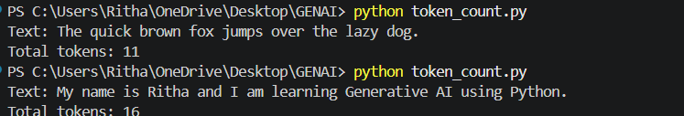

from google import genai

client = genai.Client(api_key="****b8RN6JukkdZPi5cOaM6aPQcsivTIQCHjPGEdCOVYB8AzU****")

prompt = "Explain Artificial Intelligence in simple language."

response = client.models.generate_content(
model="gemini-3.6-flash",
contents=prompt
)

print("AI Response:")
print(response.text)

print("\nInput tokens:", response.usage_metadata.prompt_token_count)
print("Output tokens:", response.usage_metadata.candidates_token_count)
print("Total tokens:", response.usage_metadata.total_token_count)

O/P
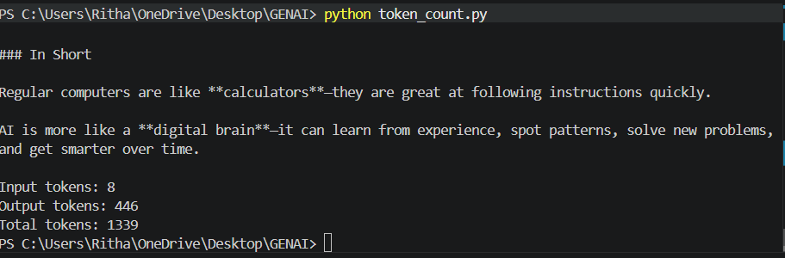

The reason is that 1339 can include additional token usage associated with the request, depending on the model/API features involved. It is not necessarily just the simple sum of the two fields you printed.

